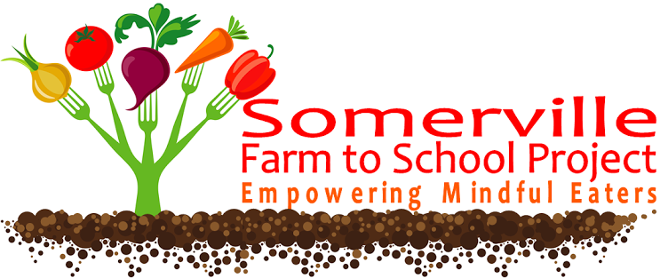
http://somervillefarmtoschool.blogspot.com/
http://somervilleearlyeducation.blogspot.com/2015/05/get-ready-to-get-
http://www.somerville.k12.ma.us/education/components/scrapbook/default.php?sectiondetailid=19858
TUFTS UNIVERSITY-Community Relations
http://communityrelations.tufts.edu/communityday/

